My Assignment……

<!DOCTYPE html>

<html lang="en">

<head>

    <meta charset="UTF-8">

    <meta name="viewport" content="width=device-width, initial-scale=1.0">

    <title>< Art Gallery</title>

</head>

<body>

    <h1>MY ART GALLERY</h1>

    <p>this is the page dedicated to the artworks and some greats arts:</p>

    <p>Below are the details of some famous art pieces and their artists:-</p>

    <h2>1.Mona lisa - by Leonardo da vinci</h2>

    <p>The Mona Lisa is a Renaissance oil portrait by Leonardo da Vinci, created between 1503 and 1519 and now housed in the Louvre Museum in Paris. Believed to depict Lisa del Giocondo, the painting is celebrated for its innovative techniques, particularly sfumato, which creates soft, blurred transitions and contributes to the sitter's enigmatic smile and lifelike presence. The painting's history, including its acquisition by King Francis I of France and its famous 1911 theft and recovery, has further cemented its status as the world's most famous and recognized artwork.</p>

    <img src="mona lisa.png" alt="">

    <h2>2.Starry Night - by Vincent van Gogh</h2>

    <p>A "starry night" describes the awe-inspiring sight of the night sky filled with twinkling stars, creating a breathtaking spectacle that can inspire feelings of wonder and connection to the vast universe. </p>

    <img src="starry nights.png" alt="">

    <h2>3.The Scream -  by Edvard Munch</h2>

    <p>The Scream is a famous art composition created by Norwegian artist Edvard Munch in 1893, becoming a universal symbol of angst and despair. Inspired by a panic attack Munch experienced, the painting depicts a figure with hands to its ears, blocking out a perceived scream passing through nature under a blood-red sky. The artwork is a seminal example of the Expressionist movement, focusing on intense emotions and distorted forms to convey inner psychological states. </p>

    <img src="the scream.png" alt="">

    <h2>4.The Birth of Venus -  by Sandro Botticelli</h2>

    <p>"The Birth of Venus" most commonly refers to Sandro Botticelli's 1485 masterpiece, a painting in the Uffizi Gallery depicting the goddess Venus emerging from the sea on a scallop shell, blown to shore by the wind gods and greeted by Spring. Inspired by Greek and Roman mythology and the Medici family, the painting was a revolutionary work for its use of non-Christian nudity and humanist depiction of beauty, using classical references while also showing a unique, flowing style.</p>

    <img src="venus.png" alt="">

    <h2>5.Guernica - by Pablo Picasso</h2>

    <p>Guernica" refers to both the small Basque town in northern Spain that was the site of a brutal aerial bombing in 1937 and Pablo Picasso's monumental 1937 oil painting created in response to that attack. </p>

    <img src="gnh.png" alt=""> *<!--*

*In this section i descibed some famous paintings and use their images for this i used paragraph tag, image tag, headings tags-->*

    <br><br><br>

    <P>Some rules to create your own artworks and important details regarding artworks are written below:</P>

    <ol>

<li>Develop a Business Plan: Outline your gallery's mission, target audience, marketing strategy, and financial projections. </li>

<li>Financial Planning: Create a detailed budget covering startup costs, rent, insurance, marketing, and artist commissions.

</li>

<li>Legal Structure & Registration: Choose a legal entity (e.g., LLC), register your business, and secure necessary permits and licenses.

</li>

<li>Business Banking & Insurance: Set up a dedicated business bank account and obtain appropriate business insurance. </li>

<br><br><br>

<p>Some techniques and materials regarding artwork are given below:- </p>

    </ol>

    <ul>

        <li>Drill & Drill Bits: For securing hanging hardware.</li>

        <li>Cordless Drill/Screwdriver: For efficient installation.</li>

        <li>Small Hammer: For minor adjustments.</li>

        <li>Tape Measure & Small Level: For accurate and level placement of artworks.</li>

        <li>Paint & Brushes: For touching up walls and pedestals.</li>

        <li>Spackle: A small container of spackle to fill any holes or imperfections in the walls.</li>

        <li>Sandpaper: To smooth out repaired areas.</li>

        <li>Melamine Cleaning Sponge (like a Magic Eraser): To quickly remove scuff marks from walls and pedestals.</li>

    </ul>

*<!--In this section i described the rules for making art gallery and some materials and techniques used in artworks by using lists tags ordered and unordered-->*

    <br><br><br>

    <p>Below is a comparison art table on the basis of their cost you can check it out:-</p>

    <table>

        <tr>

            <th>type</th>

            <th>Dimensions</th>

            <th>value</th>

        </tr>

        <tr>

            <td>Unframed painting</td>

            <td>80*100cm</td>

            <td>5000 euro</td>

        </tr>

        <tr><td>Ceramic sculpture</td>

            <td>50*50*80</td>

            <td>12000 euro</td>

        </tr>

        <tr>

            <td>Unframed drawing</td>

            <td>30*40cm</td>

            <td>500 euro</td>

        </tr>

*<!-- in this section i made a table comparing cost on their basis-using table tag ,table rows ,table data-->*

    </table>

    <br><br><br>

    <p>Below are the links of some artworks u can go through them once:-</p>

    <a href="https://youtu.be/uP1HBlGfmkk?si=Ji7ecVYDMZ0tVU5R">Link 1</a>

    <a href="https://youtu.be/5dXFqVnkCdA?si=M-1HBH-_OreOmKO8">Link 2</a>

    <br><br><br>

    <h1>Thank you for visiting</h1>

</body>

</html>

Output….

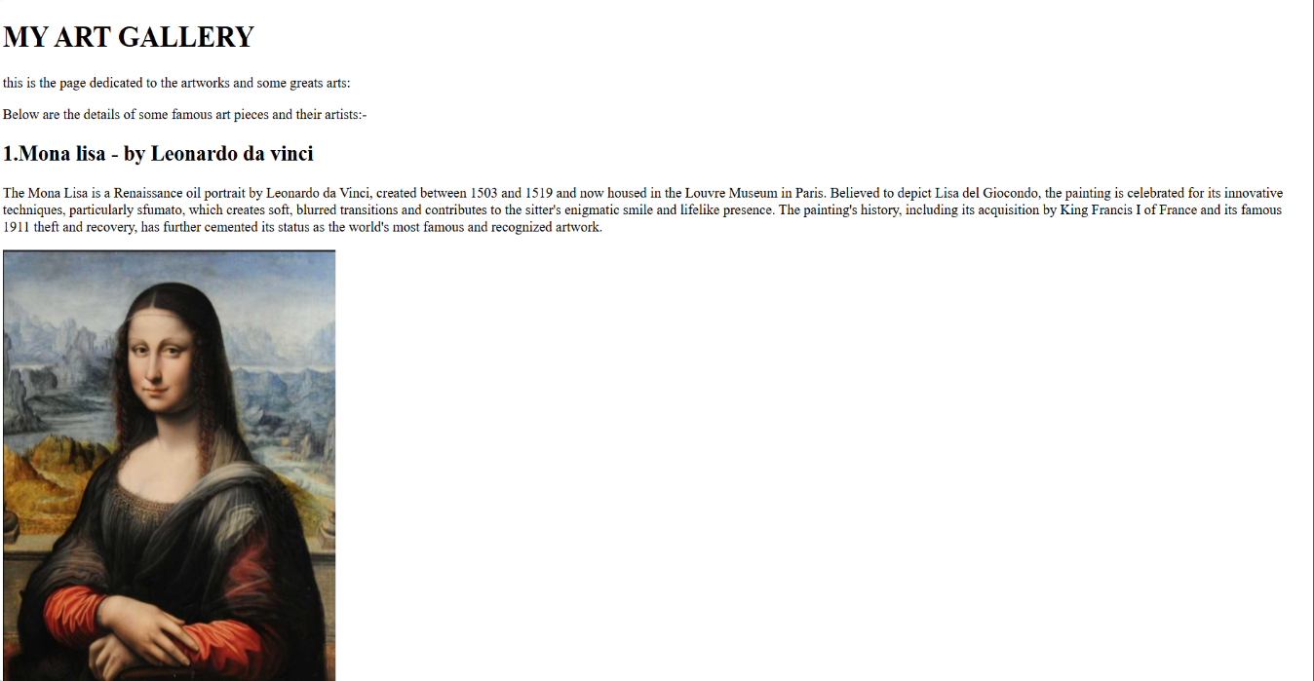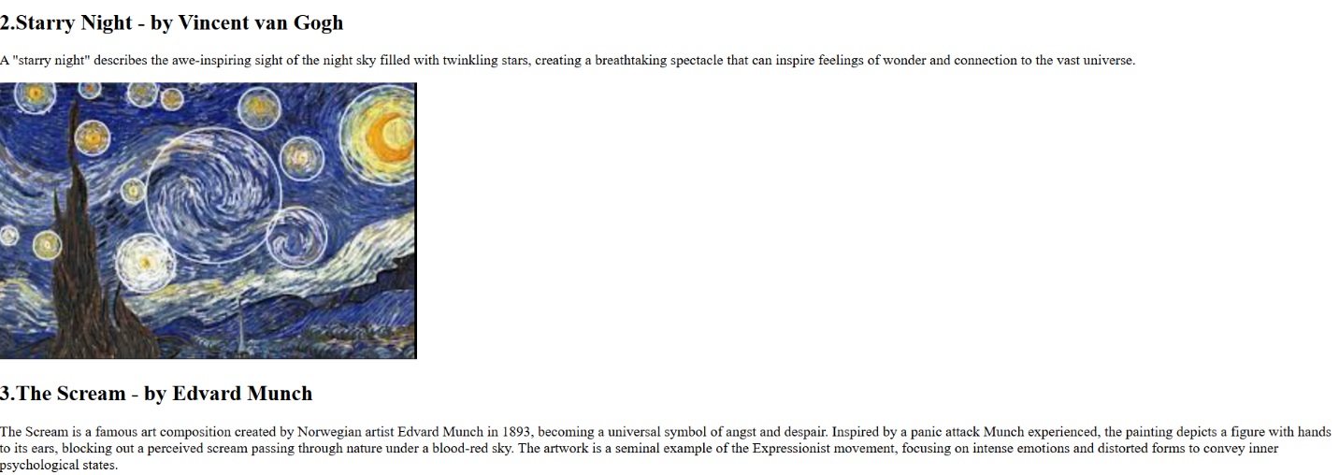

Name- Jai Arora

Class-CSE (AI B)

Roll no-2025R00311C01165